sadasd

Claims Process

Bizagi Modeler

Table of Contents

Claims Process 1

Bizagi Modeler 1

1 UVL New Claim Set-Up 3

1.1 New Claim Set-Up 4

1.1.1 Process Elements 4

1.1.1.1 Email Received 4

1.1.1.2 Exclusive Gateway 4

1.1.1.3 Create Customer File in OneDrive 5

1.1.1.4 Log into United Portal 6

1.1.1.5 Navigate to ADCC 7

1.1.1.6 Open Search Option 8

1.1.1.7 Search for Customer File 8

1.1.1.8 Open Claim File 9

1.1.1.9 Edit BOKR Participant 9

1.1.1.10 Add new Participant as BOKR 12

1.1.1.11 Get PDF Claim Form & Photos 15

1.1.1.12 Save PDF Claim and Photos 17

1.1.1.13 Save ACS Cover & Overview to Customer File 19

1.1.1.14 Update ACS Cover & Overview from Claim PDF 20

1.1.1.15 Sign into MS 21

1.1.1.16 Open Claims Module 22

1.1.1.17 Verify no HHG claim already set up in MS 22

1.1.1.18 Add claim to MS 24

1.1.1.19 Add claim items 27

1.1.1.20 Add Note in MS 29

1.1.1.21 Set Task for adjuster 31

1.1.1.22 Add Note in MS 33

1.1.1.23 Move Email 35

UVL New Claim Set-Up

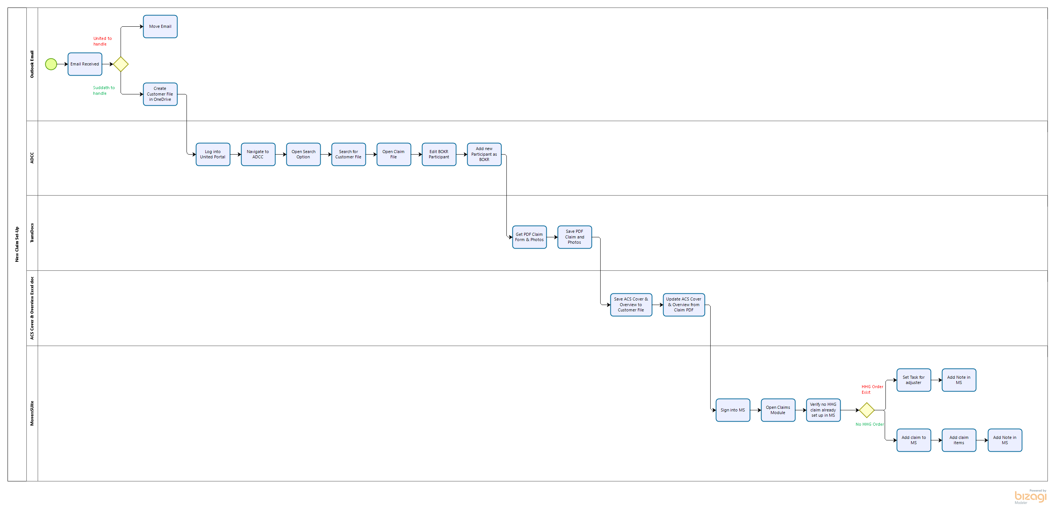

Version:

1.0

Author:

RHager

New Claim Set-Up

Process Elements

Email Received

Description

Email notification of a new claim being filed with United is received at corporateclaims@suddth.com from UGClaims@unigroup.com.

Screen Shot

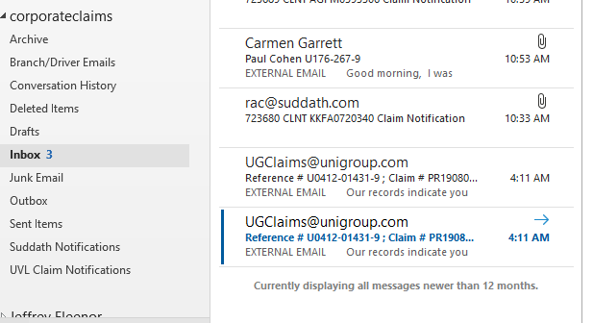

Exclusive Gateway

Description

If claim status is registered and the claim is assigned to Kelly Hardiman Suddath will handle the claim. It will be pulled from United and set up.

Screen Shot

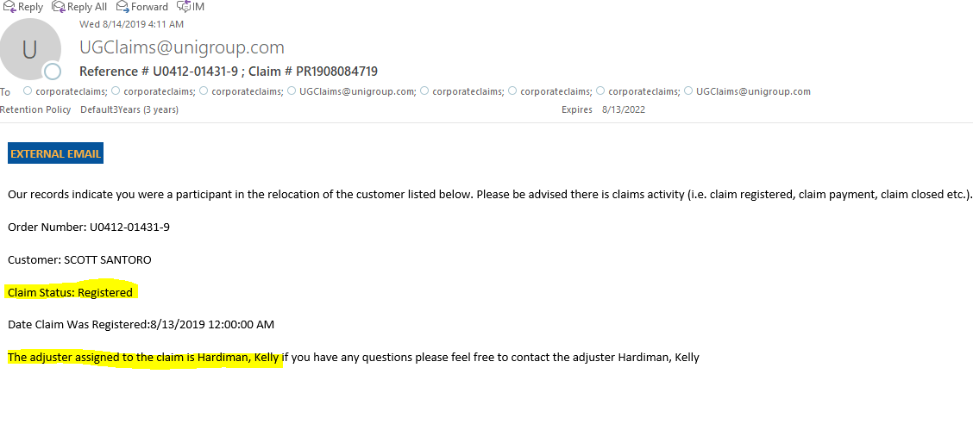

Gates

United to handle

Suddath to handle

Create Customer File in OneDrive

Description

Create customer folder in OneDrive.

File name should be formated as follows:

Order Number and Customer Name from email

If there is already a folder do not set up a new one

Screen Shot

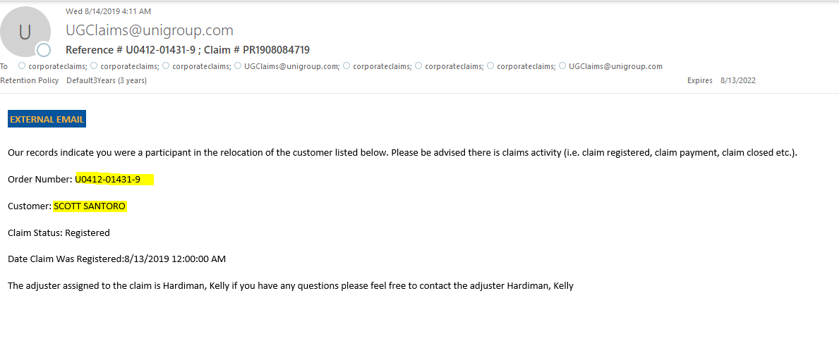

Screen Shot 2

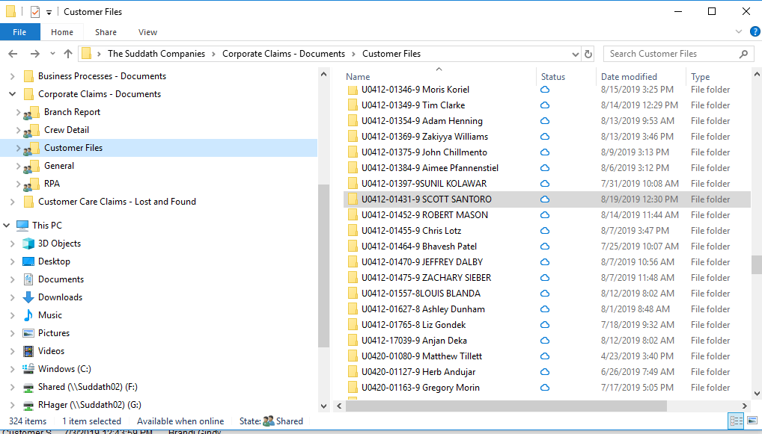

Log into United Portal

Description

Log into United Portal

***Note if password change is needed it can be changed using the current password***

Online Claim Link

<https://portal.unigroupinc.com/wpsecure/wps/myportal>

Screen Shot

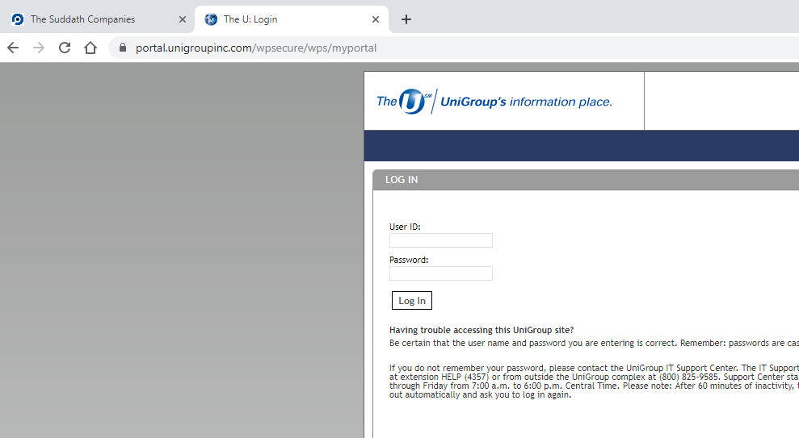

Navigate to ADCC

Online Claim Link

<https://portal.unigroupinc.com/clm/PRD_AFS.Claims/Desktop/HomePage/Default.aspx?src=%2fPRD_AFS.Claims%2fDesktop%2fHomePage%2fHomePage.aspx&IframeMode=true&UserStateId=A50B7778F20EAB75>

Screen Shot

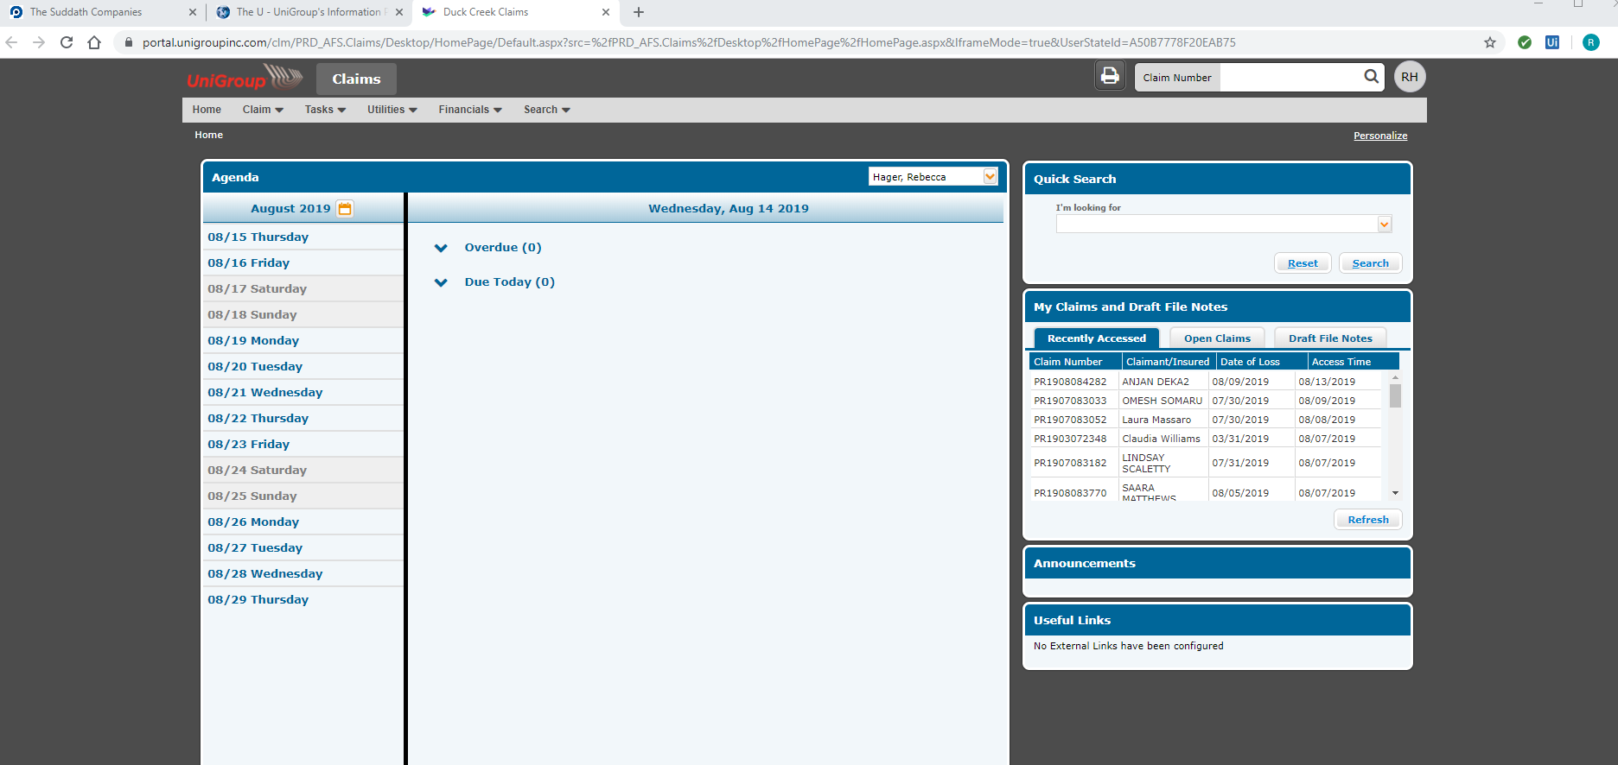

Open Search Option

Description

Hover over the search option at the top of the screen. Click on Reference Number

Screen Shot

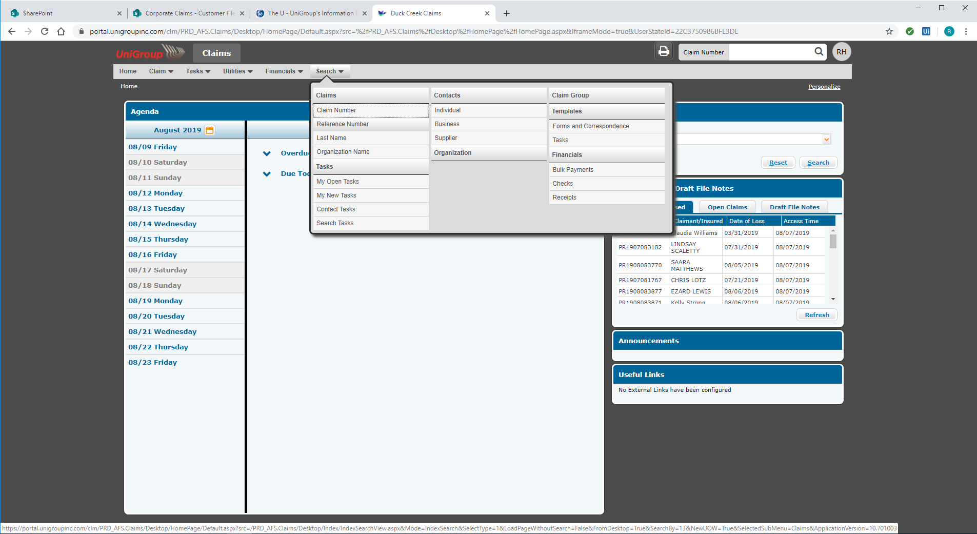

Search for Customer File

Description

Enter Order Number from email into search field and click on the search button

Screen Shot

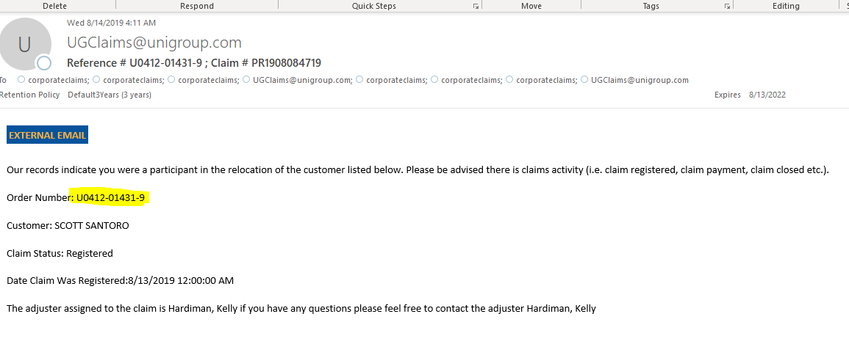

Screen Shot 2

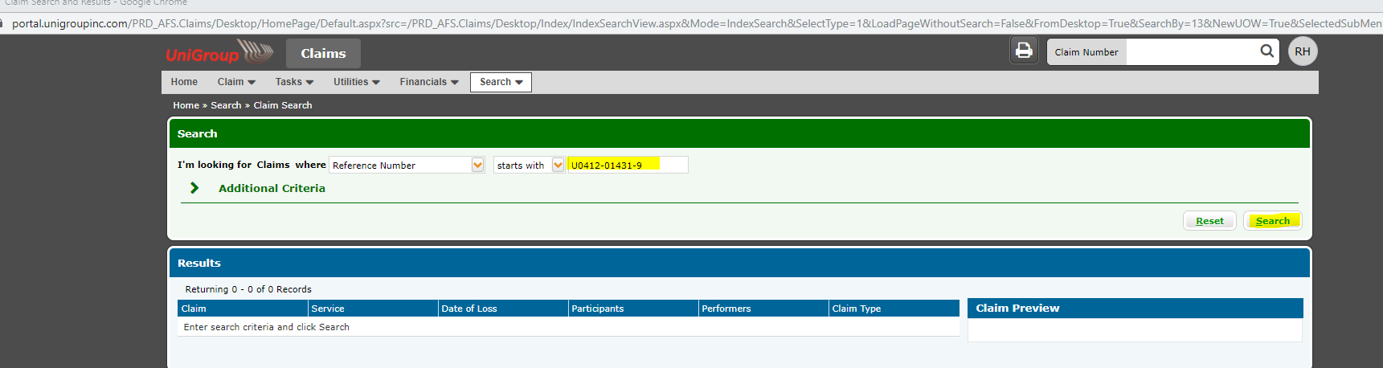

Open Claim File

Description

Click on Claim Number (begins with PR) that has a claim type of CARGO

There may be two options if there is another claim type such as Delay. We want to match the claim type to CARGO

Screen Shot

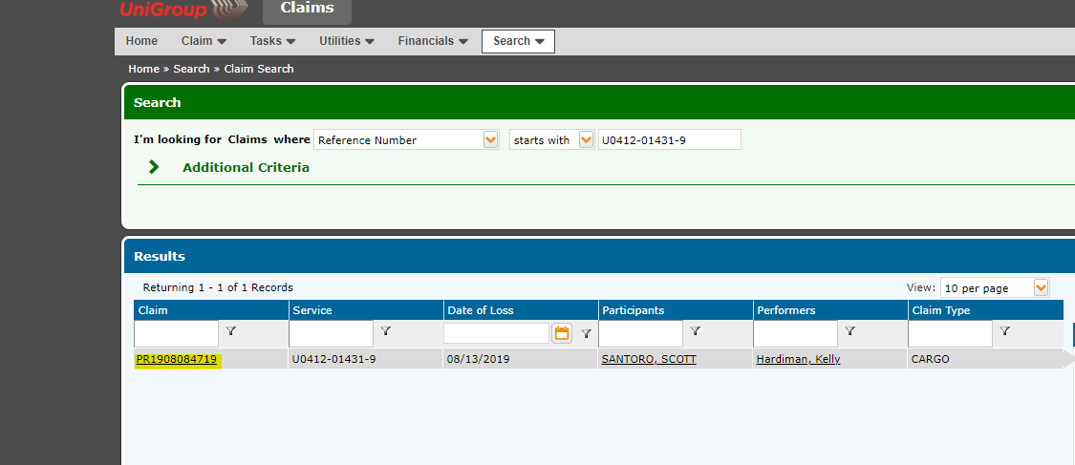

Edit BOKR Participant

Description

Click on View All Participants under the Participants box on the right hand side.

Select the Participant that has a role of BOKR

Click Edit

Choose drop down list under Roles and unselect BOKR by clicking on the radio box

Click Save

Screen Shot

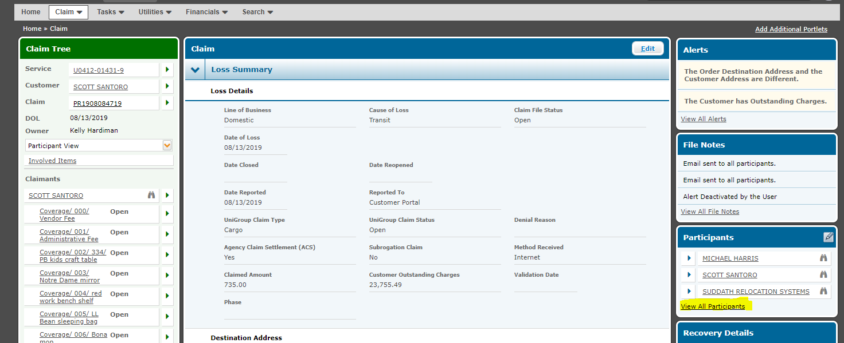

Screen Shot 2

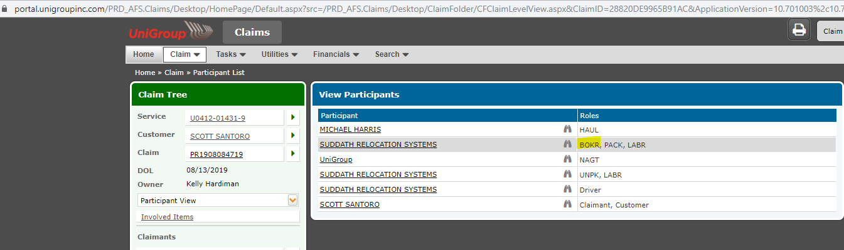

Screen Shot 3

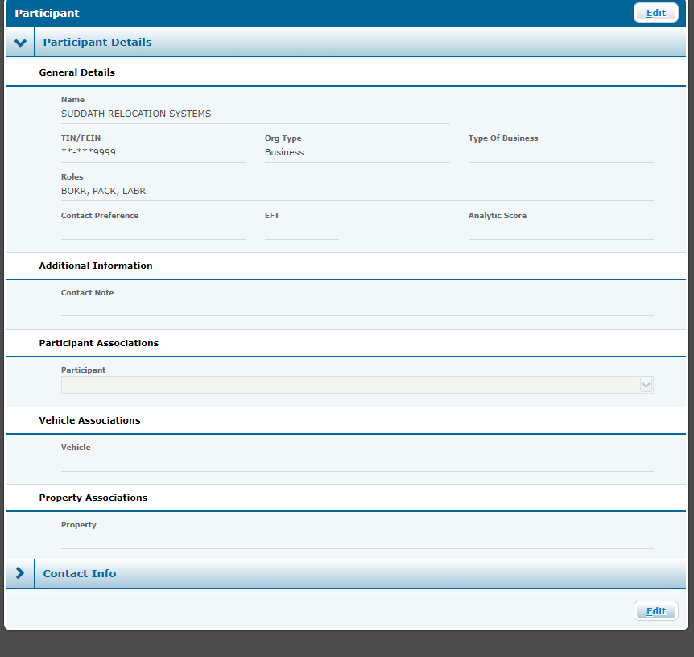

Screen Shot 4

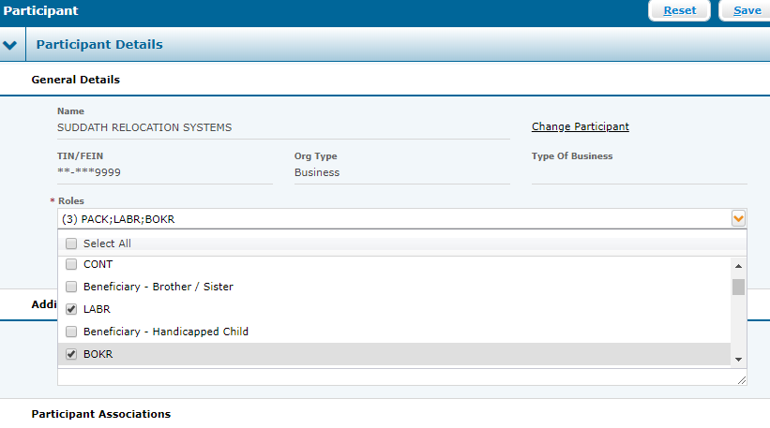

Add new Participant as BOKR

Description

Click on Add a Participant under the I Need To box on the left hand side.

In the search criteria type in the below in the correct field:

I'm looking for = Agency

where = Agency Number

last field type 420

Click Search

Click on the radio button for Suddath Relocation Systems

Click Select

Type BOKR in drop down field under Roles

Hit Enter

Click Save

Close ADCC

Screen Shot

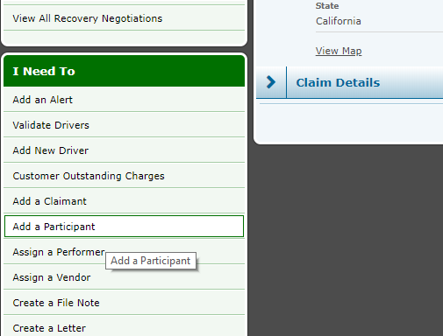

Screen Shot 2

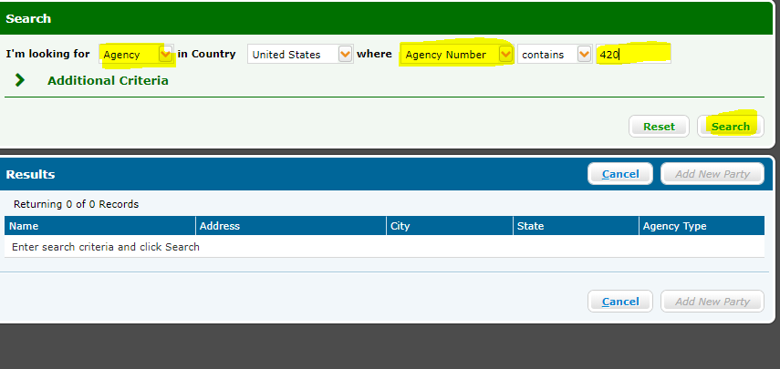

Screen Shot 3

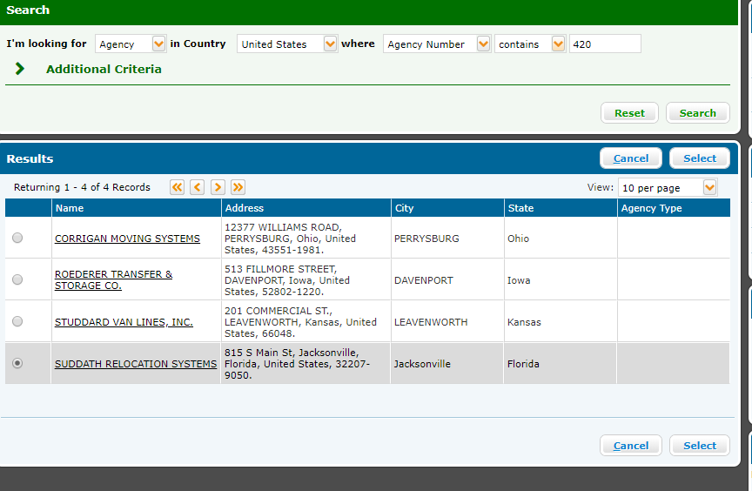

Screen Shot 4

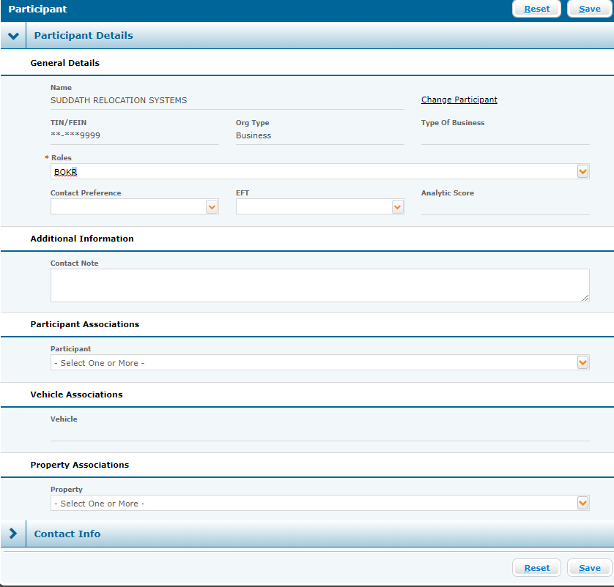

Get PDF Claim Form & Photos

Description

Navigate to Transdocs (link attached)

Click on Imaging System

Enter order number in the below format. You do not keep the placement 0's and you have to separate the begining character by a dash.

U0412-01431-9 = U-412-1431-9

Click radio button for include claim documents

Click Search

Click radio button for the below and click view as single PDF

CLM CLAIMS FORM

PIC PICTURES

***NOTE - There should always be a claim form, but there may not always be pictures.****

Online Claim Link

<https://portal.unigroupinc.com/transdocz/tsgdocz/Logon.do>

Screen Shot

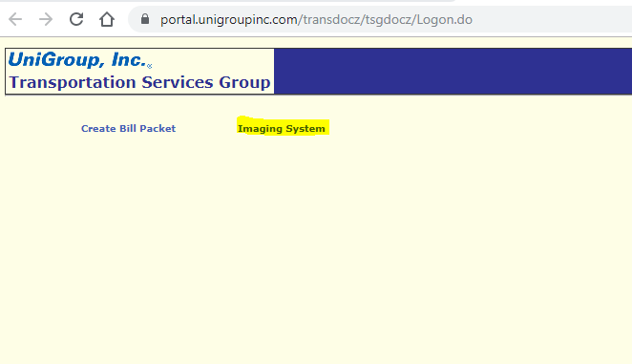

Screen Shot 2

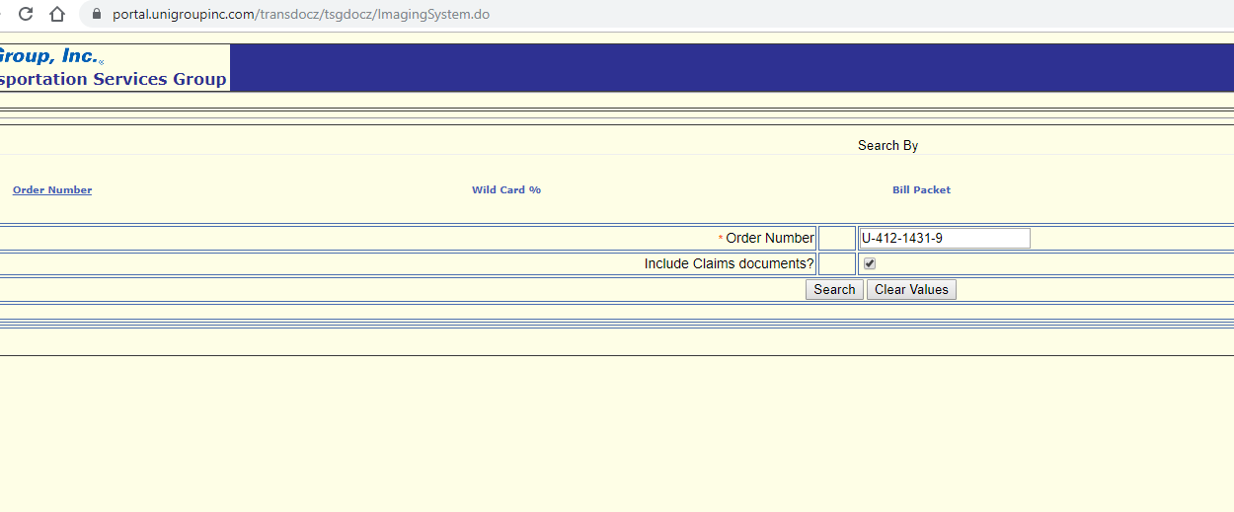

Screen Shot 3

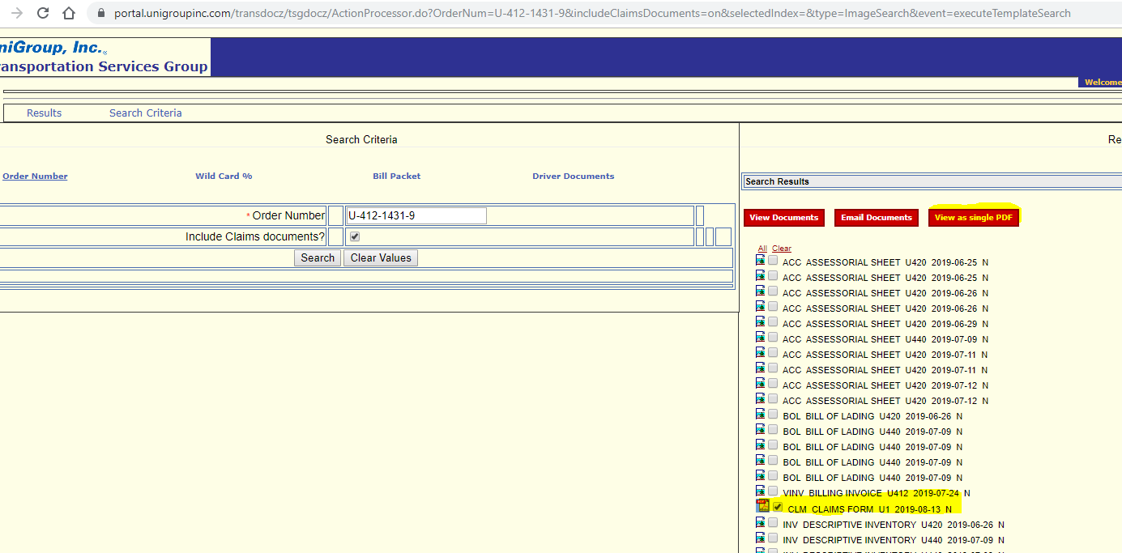

Save PDF Claim and Photos

Description

Click the print icon at top right of screen

Set Destination as Save as PDF

Click Save

Change name of document to Claim Form

Save to Customer File in OneDrive

Screen Shot

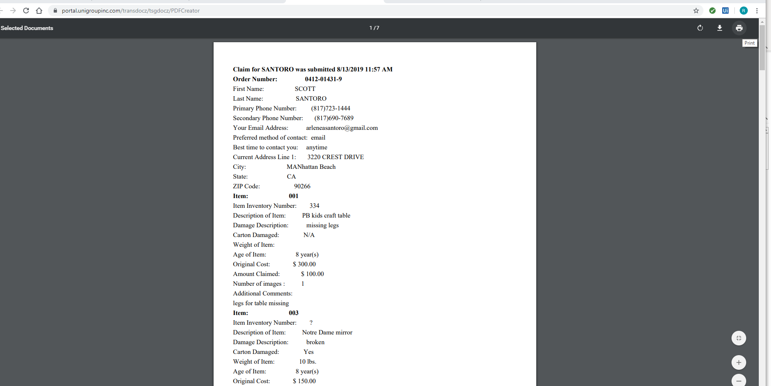

Screen Shot 2

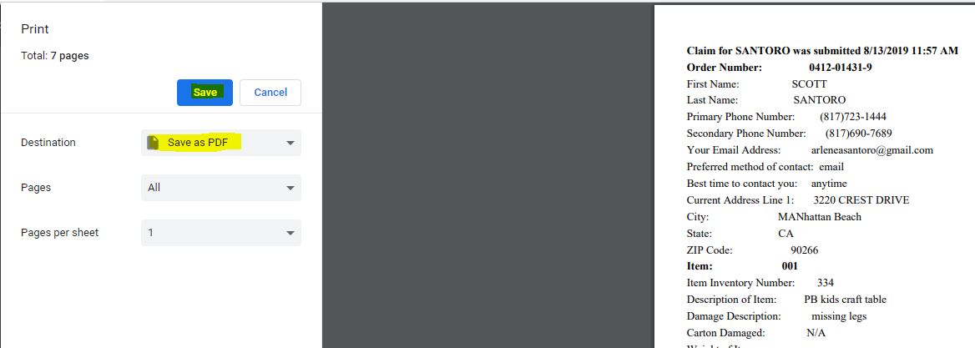

Screen Shot 3

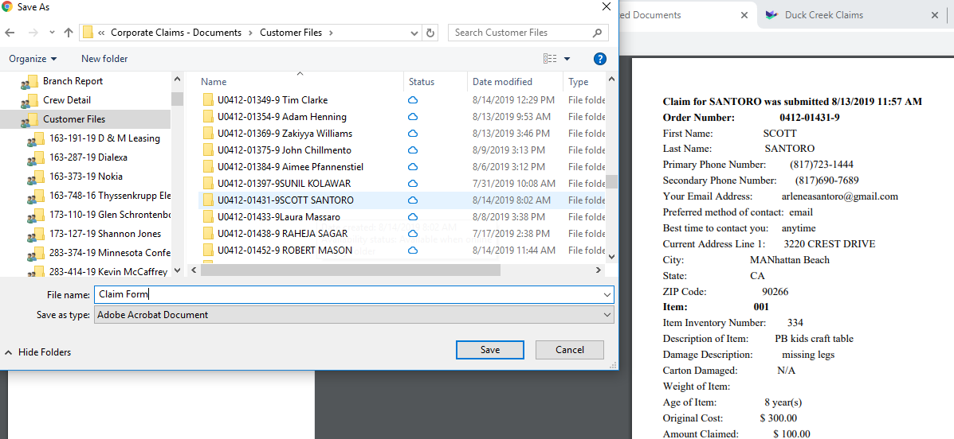

Save ACS Cover & Overview to Customer File

Description

Go to Claim Docments Folder

C:\Users\rhager\The Suddath Companies\Corporate Claims - Documents\General\Claim Documents

Right click on ACS Cover & Overview

Click Copy

Open Customer File from below folder

C:\Users\rhager\The Suddath Companies\Corporate Claims - Documents\Customer Files

Paste into file

Screen Shot

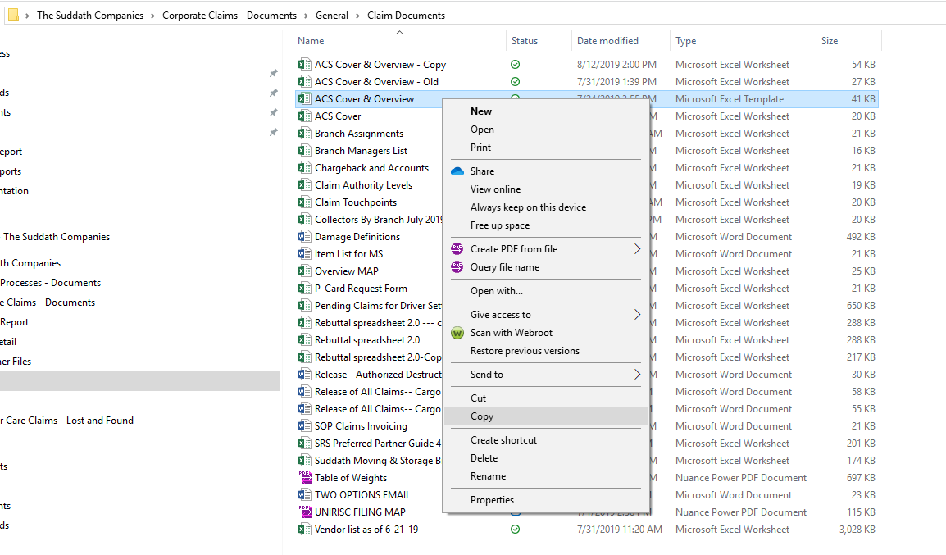

Screen Shot 2

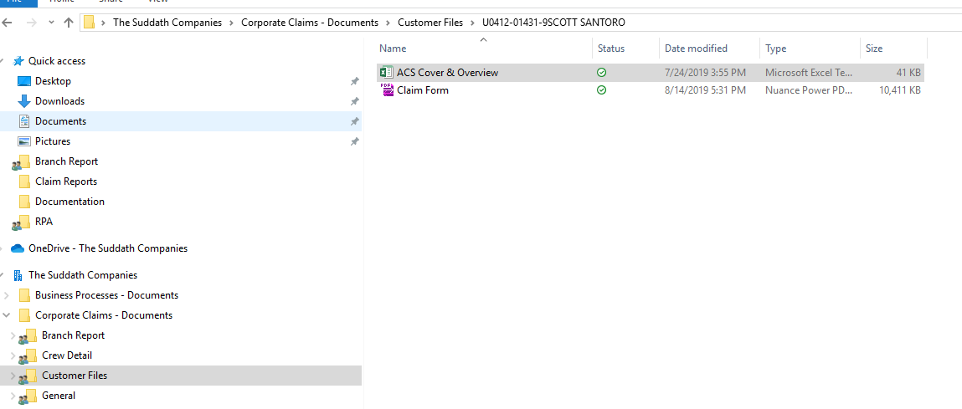

Update ACS Cover & Overview from Claim PDF

Description

Update overview with data from PDF claim form.

Screen Shot

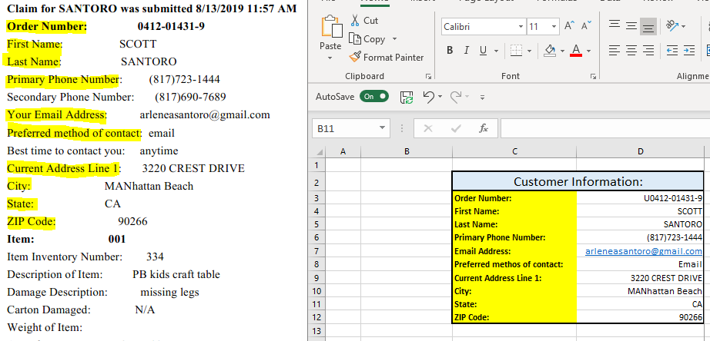

Screen Shot 2

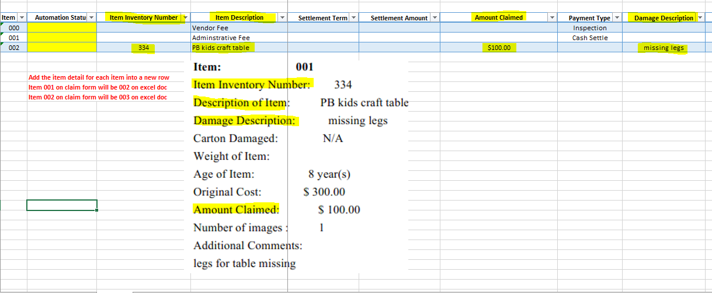

Sign into MS

Description

Open MS

Screen Shot

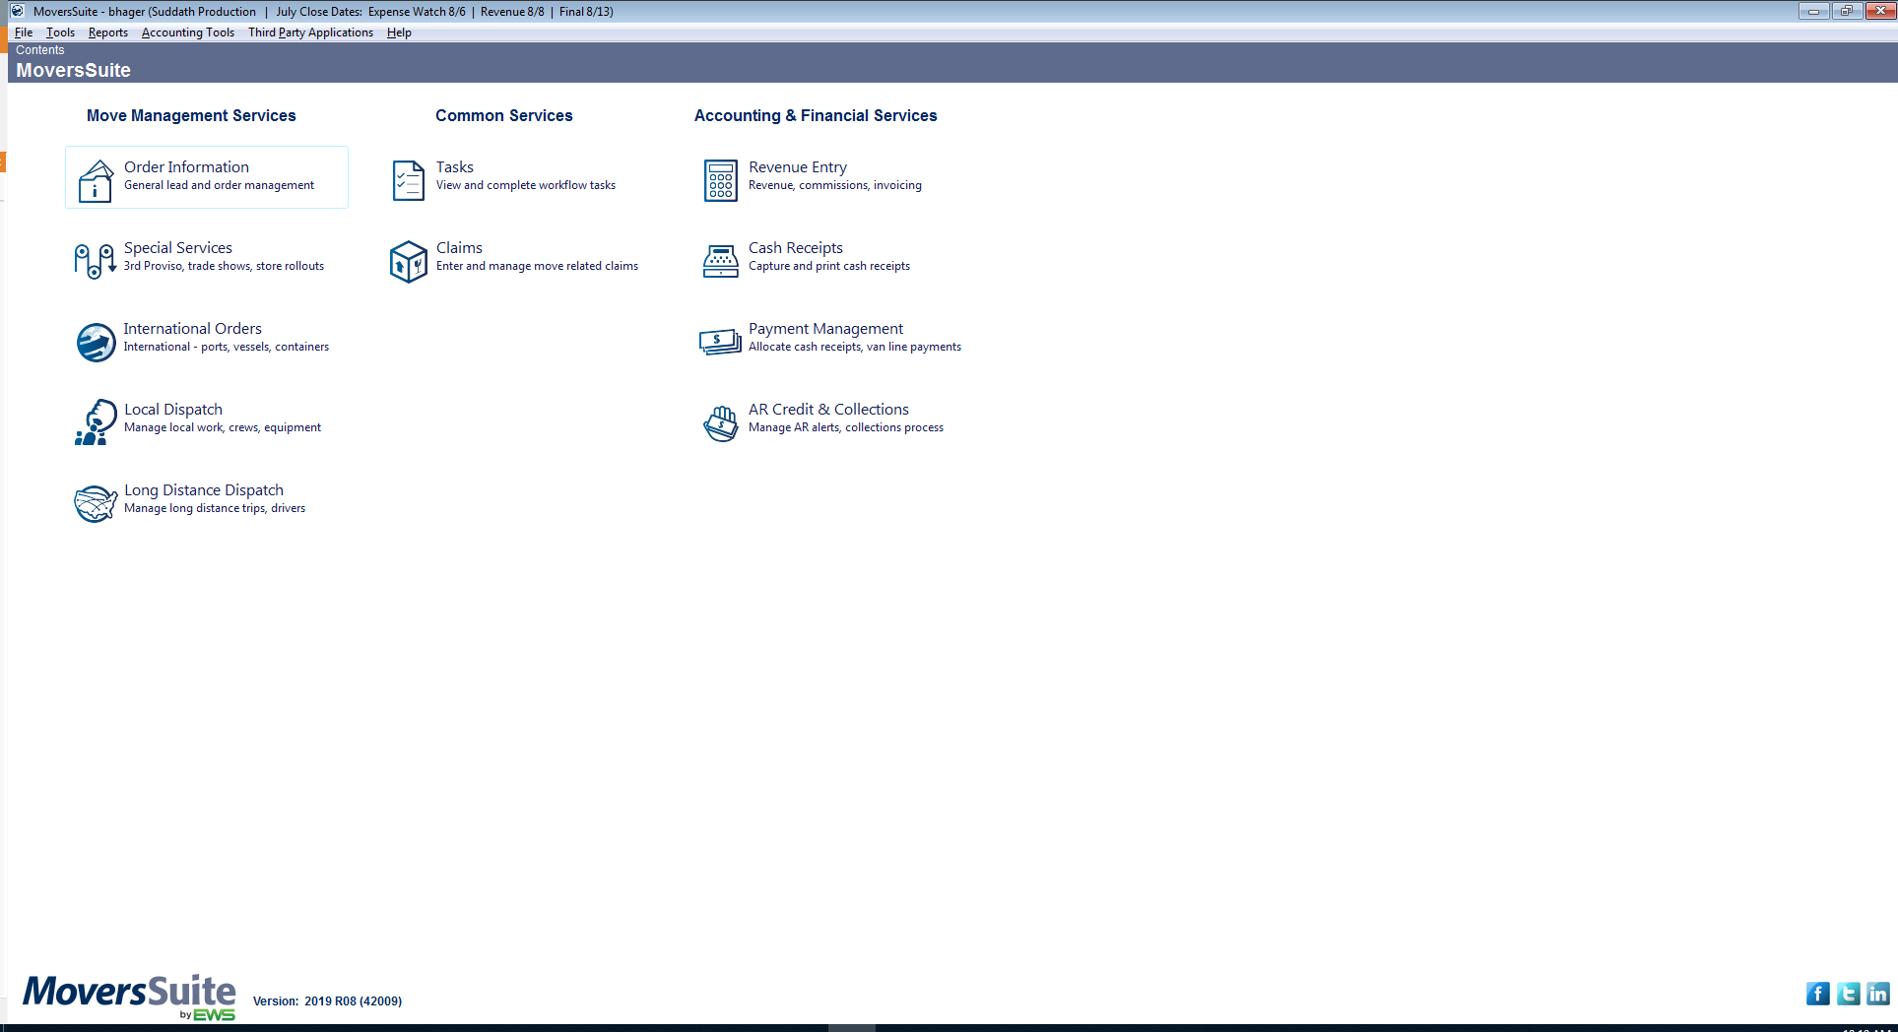

Open Claims Module

Description

Click on Claims under Common Services from Contents Page

Screen Shot

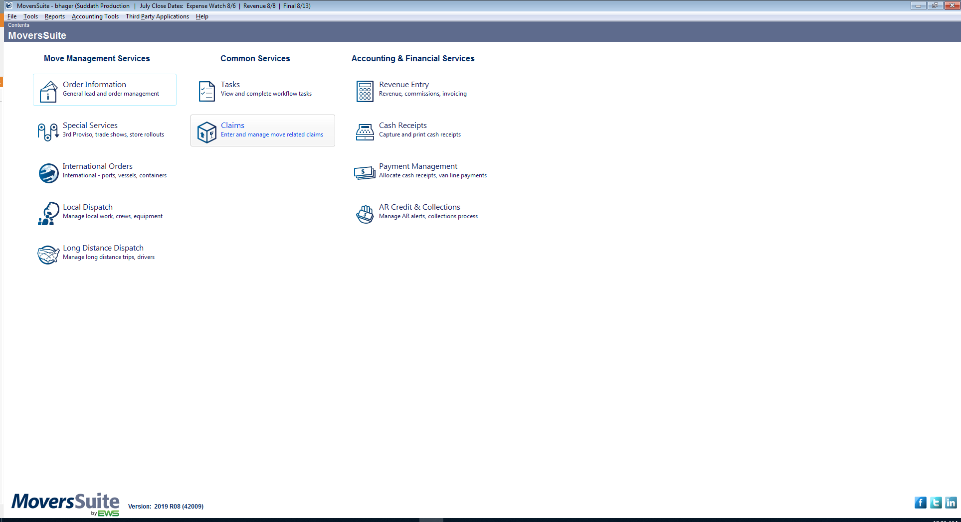

Verify no HHG claim already set up in MS

Description

Click on Find

When the search box pops up, click on the Order Information tab.

Type the order number in to search for the claim.

Click Find

***NOTE - The MoversSuite order number does not have the placement 0.

Claim Form/Folder/ADCC = U0412-01431-9

MoversSuite = U412-1431-9

Screen Shot

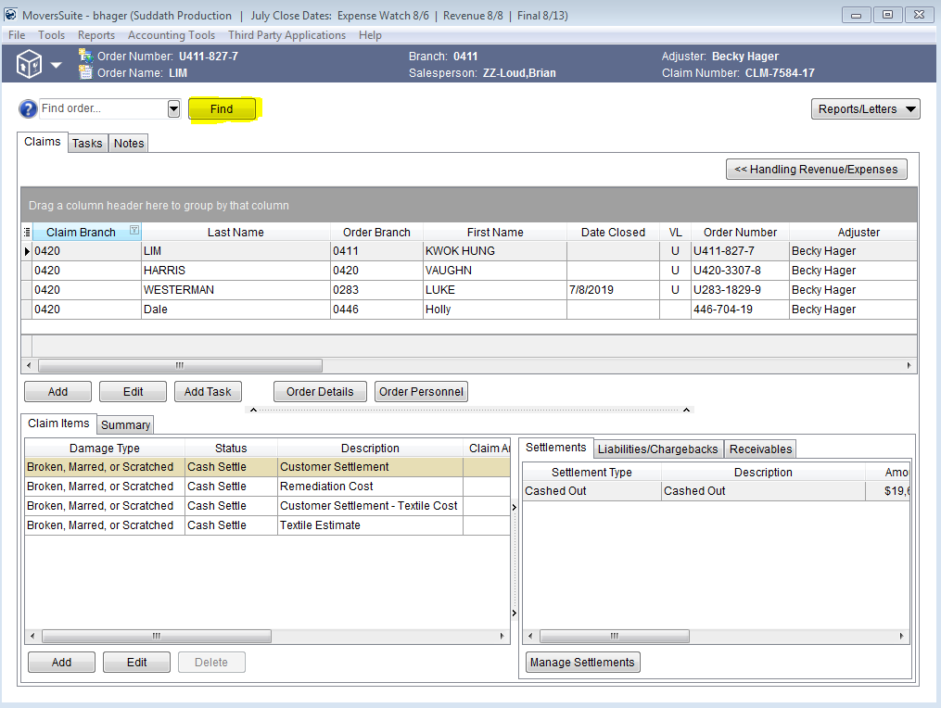

Screen Shot 2

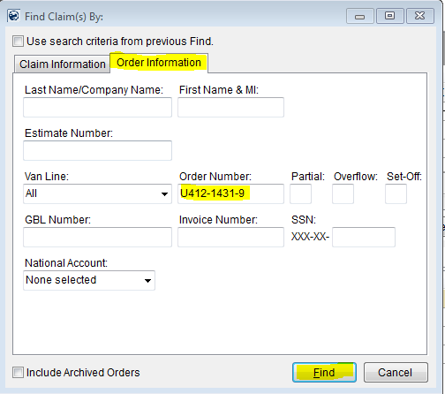

Add claim to MS

Description

Click add in the middle of the MS module

Type in order number

click Find

***NOTE - if two options are found, only choose the order that does not have a trailing letter example:

U412-1431-9 -A- = don't chose

U412-1431-9 - Chose

Enter the claim detail information from the ACS Cover & Overview:

Amount claimed

Home Phone

Email1

Address

City, State

Zip Code

The adjuster will be assigned based on the assignment sheet excel document.

The below information will always be as indicated:

Branch = 0420

Type = HHG Claim

Status = Open

Task Definition = Claims

Actual Claim Received = Type "Today"

Screen Shot

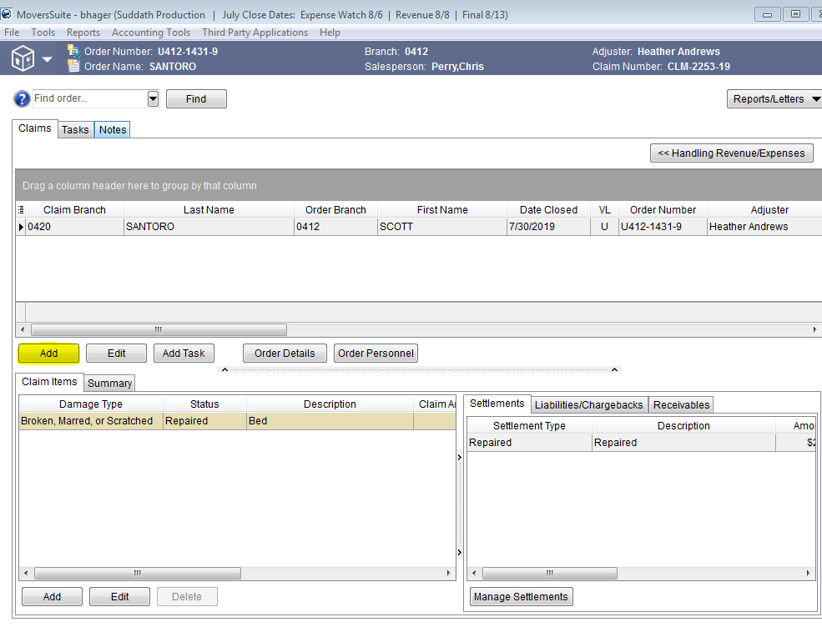

Screen Shot 2

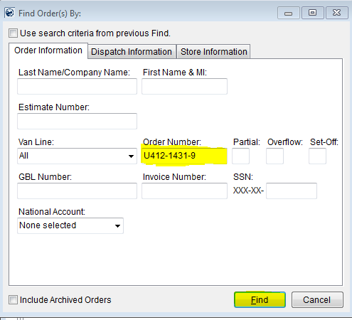

Screen Shot 3

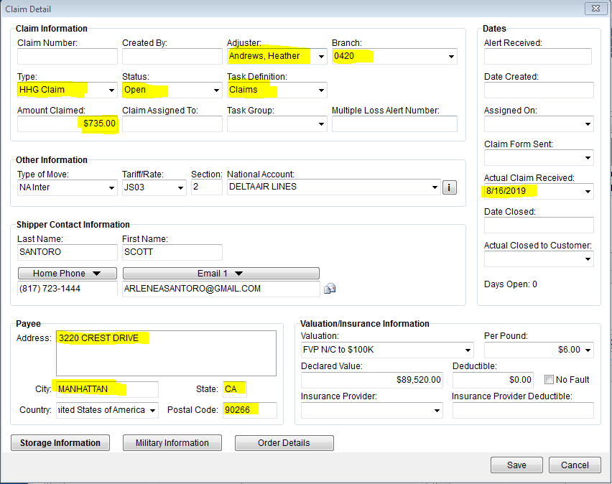

Screen Shot 4

|  |  |  |  |  |
| --- | --- | --- | --- | --- |
| Heather Andrews | Bea | Dania | Jean | Tina |
| 412 Delta | 420 Facebook/Altair | 283 | 411 | 420 Lexicon |
| 420 IRCO | 489 | 440 | 470 | 163 |
|  | 173 | 444 | 483 | MLA |
|  | 458 | 452 | 488 | 412 |
|  |  | 420 Rotation | 420 Rotation | 446 |

Add claim items

Description

Click add at the bottom of the screen

For each item fill in the below information from the ACS Cover & Overview:

Description = Item Description

Exceptions Noted = Damage Description

Tag Number = Item Inventory Number

Claim Amount = Amount Claimed

The below information will will always be the same:

Damage Type = Broken, Marred, or Scratched

Item Status = In Process

Click Save

Repeat for every item on ACS Cover & Overview

Screen Shot

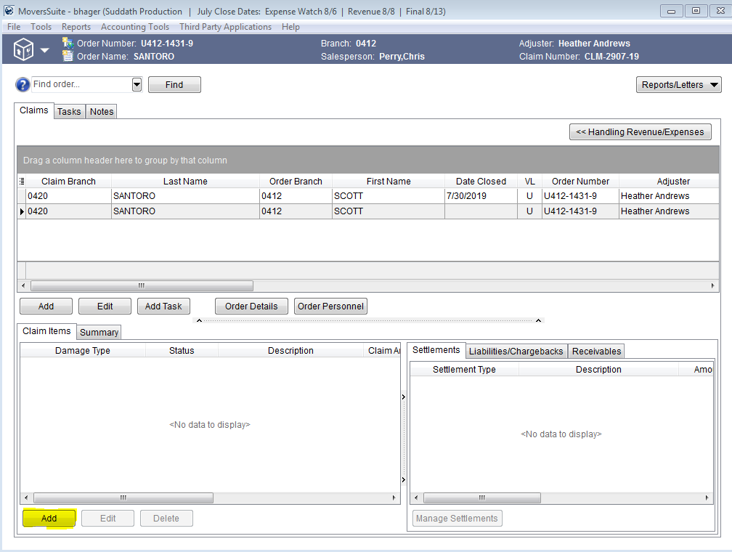

Screen Shot 2

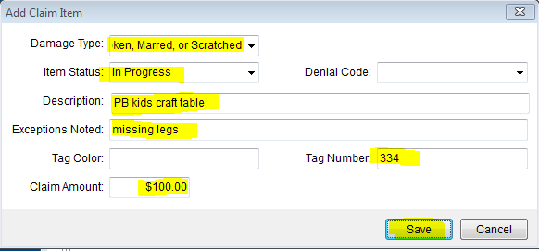

Add Note in MS

Description

Click Notes tab on top, click Add Notes

Enter the following information:

Type - CCLM^- Claim Comments

Subject - HHG Claim Received

Memo: Assigned to (insert adjuster name)

Check the radial box by Enabled

Type initials (ROB).

Click Save

Screen Shot

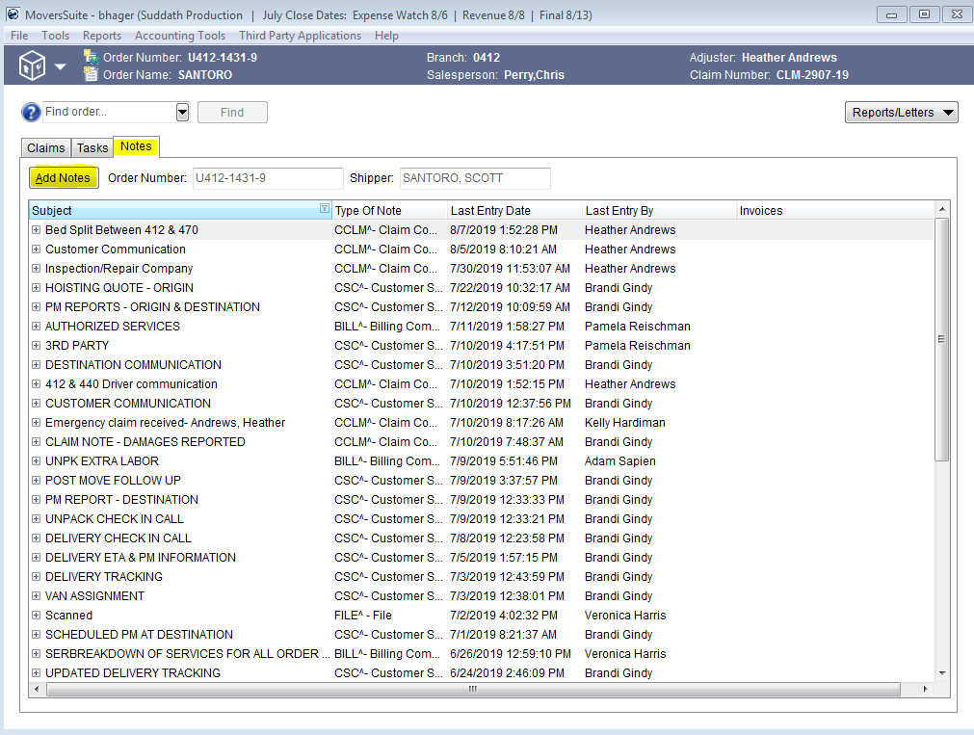

Screen Shot 2

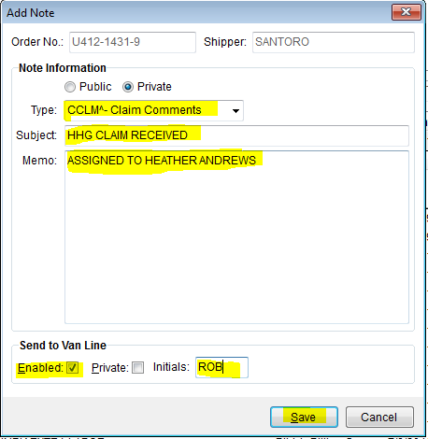

Set Task for adjuster

Description

If there is already a claim set up in MS that has a Type of HHG Claim:

Click on the Task tab

Click on Add Task

Type the below information in the appropriate fields:

Task Description = Supplemental Claim Received

User Type = Claims Adjuster

Enter Task Due Date = Today

Click Save

Screen Shot

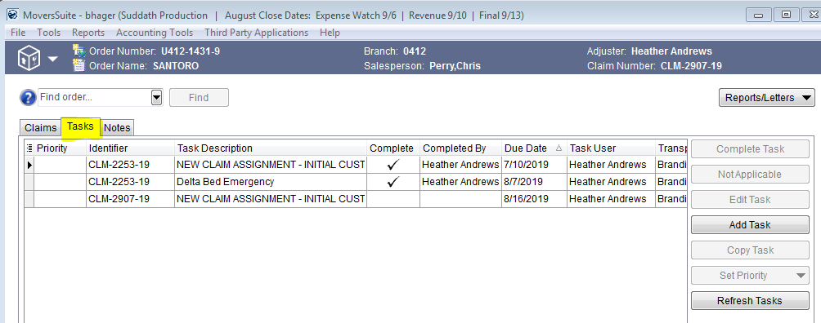

Screen Shot 2

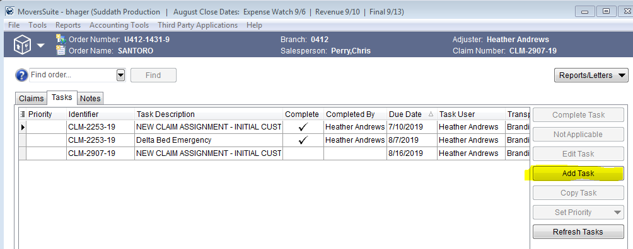

Screen Shot 3

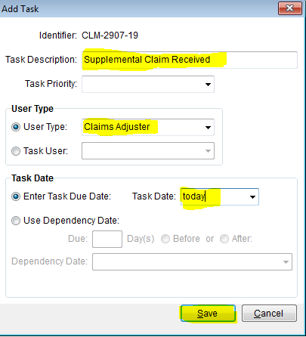

Add Note in MS

Description

Click Notes tab on top, click Add Notes

Enter the following information:

Type - CCLM^- Claim Comments

Subject - HHG Supplemental Claim Received

Memo - HHG Supplemental Claim Received

Check the radial box by Enabled

Type initials (ROB).

Click Save

Screen Shot

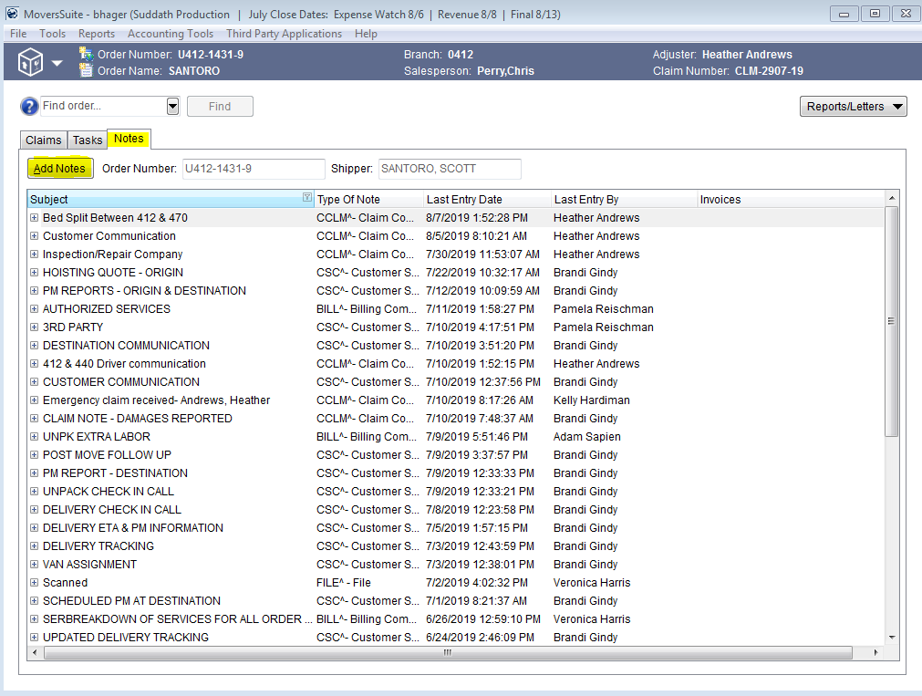

Screen Shot 2

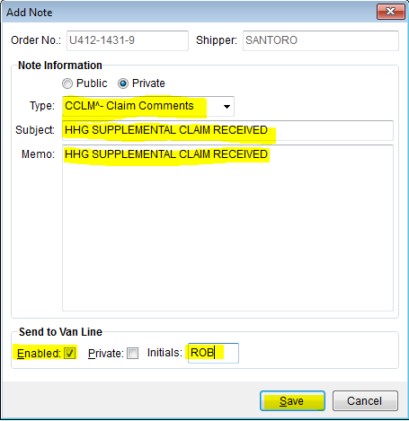

Move Email

Description

If the claim is not registered and assigned to Kelly Hardiman the email can be moved to the UVL Claim Notifications folder in [corporateclaims@suddath.com](mailto:corporateclaims@suddath.com)

Screen Shot

